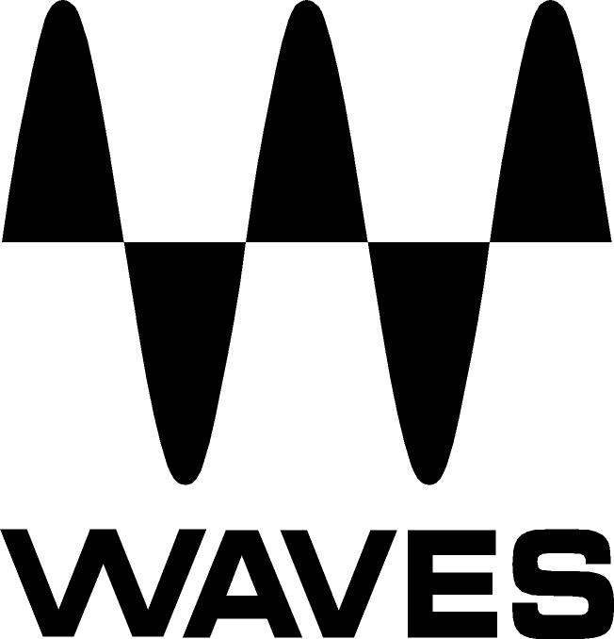
PRESS RELEASE
Contact: Clyne Media, Inc.
Tel: (615) 662-1616
Fax: (615) 662-1636

FOR IMMEDIATE RELEASE

Asaf Avidan “Anagnorisis” Tour Chooses the Waves eMotion LV1 Mixer

Knoxville, TN, October 28, 2021 — Touring during COVID has created new challenges for live productions worldwide, with restrictions and uncertainties requiring a more flexible, lightweight, FOH and monitor mixing footprint without compromise in performance. Stepping up to this challenge has been crucial to the success of platinum-certified singer/songwriter Asaf Avidan’s extensive “Anagnorisis” tour, now trekking across North America and Europe with shows scheduled through mid-2022. For this tour, FOH engineer Gil Teleman and monitor engineer Arik Finkelberg have chosen the Waves eMotion LV1 Live Mixer as their mixing solution.

“The Waves LV1 system is the future. The clean sound of the preamps especially blew our mind,” notes Teleman, remarking that the eMotion LV1 is indispensable for their sound and setup. “One of the great things about the LV1 is that it’s compact and completely modular. Its combination of small footprint, versatility and top-quality sound would be hard to beat at any time, but it’s a real godsend during this challenging era for live tours.”

“To deal with uncertain schedules and limitations during COVID, we often have to rely on flights instead of a large tour bus,” Teleman expounds. “This means we need to think very carefully about the weight and casing of the gear. I don’t need an 8-foot, 100-pound surface to get the sound I want. It makes more sense to have a setup that’s small and light, but with a ton of options for my FOH mix, and that’s exactly what I’m getting with the LV1. The setup is compact and tidy, with everything controlled easily from the Waves FIT controller plus a touchscreen or two. The mixer has great-sounding preamps and enormous headroom, and with all my Waves plugins running inside the LV1, I’ve got high-end studio sound for the shows – the kind where you want to print every show and stream it to the world.”

“When I presented this solution to the artist and management,” he adds, “everyone was thrilled; it was immediately approved. In fact, Asaf had wanted to buy some effect pedals for himself and the backing vocalists, but then he realized it wasn’t needed thanks to the Waves plugins I was going to use within the LV1. We were able to save money, weight, and the need for the musicians to handle FX.”

Teleman explains that he alternates between two setups: “For most shows, my setup is the FIT control surface combined with a self-powered mobile 15.6-inch touchscreen. The screen sits in the zipped front compartment of the backpack, and the whole thing weighs only 12 kg (26.5 lbs). I can easily put it on my back wherever I go and take it as a carry-on on the plane. My second configuration is even smaller! It's basically a touchscreen/15.6-inch laptop and that's it. I use it as an alternative for emergencies, small PR sessions, and solo shows without the full band. Occasionally, I will add a portable screen. Being able to switch seamlessly to this even smaller setup gives me a level of flexibility I couldn’t have with another mixer. Either way, we have a great-sounding setup that fits in just three Pelican 1637s, a 2U shallow case and a backpack. Both setups work amazingly well, and both have a Waves Mercury plugin bundle installed and running from within the LV1.”

In terms of processing, Teleman remarks, “Asaf's latest album has unique backing vocal parts; recreating that in the live shows was very important to him. I’m using various combinations of the Waves Vocal Bender, Doubler and CLA EchoSphere plugins to recreate that sound in the LV1, and it sounds awesome! The settings on these plugins change by the scene, from heavy add-on processing to basic thickening. My other favorite processors for this setup are the Waves F6 Floating-Band Dynamic EQ, an amazing multiband dynamic plugin that I can’t get enough of; Waves Smack Attack, which is the best transient designer I have ever worked with; and CLA MixHub, my go-to channel strip. I also use the Waves/Abbey Road EMI TG12345 as my ‘alternative’ channel strip. The Waves Primary Source Expander plugin is a must-have tool to control mic bleed; and the Manny Marroquin Signature Series bundle, especially the Drive and Delay, is thrilling to process with. Finally, I use Waves’ Abbey Road TG Mastering Chain on my master fader to finalize the concept of bringing Asaf’s studio sound to the stage.”

Monitor engineer Arik Finkelberg remarks, “Right from the get-go, when we started production rehearsals, I was really impressed with the sound quality of the LV1. Even without using plugins, the sources already sounded clean and healthy, which was very comforting to me. The guys on stage have a very high standard of how they like to hear their mix, and when I heard the channels for the first time, I knew I wouldn’t have to struggle with the sources to get there. Another thing that really blew me away was the headroom, which was surprising in the best possible way – I don't think I’ve ever heard a mixer with that much headroom; it really helped us a lot with Asaf’s vocal being extremely dynamic. Furthermore, connecting everything is very easy: it takes me only 3-5 minutes to set up start to finish, including running tests to verify that everything works properly. Everything connects to everything else via a simple Cat 6 cable. It’s great to realize things can be that simple.”

Regarding processing, Finkelberg notes, “The band wants a clean, detailed studio vibe in their ears, and for that there are some plugins I couldn’t do without. Everyone on stage is singing, and on some songs Asaf himself has two different vocal mics working together – one dry and one for FX. All these vocal mics can add up to quite a bit of bleed. The Primary Source Expander (PSE) plugin is a real life-saver here: it helps tame the bleed in a natural way that I could never get from a regular gate/expander without tweaking for hours. I just load up the PSE, and I’m almost immediately there. The Waves Doubler is also a must on vocals, as some of the songs incorporate a lot of pitch-shifting on the lead vocals and the backing vocals. For instruments, a few plugins are must-haves for me: the C6 Multiband Compressor, which I know very well from studio work, is on many of our instruments on stage, especially the large variety of guitars that Asaf plays. And the Waves Smack Attack transient shaper – which I got to know for the first time during this tour – is great for shaping the drums and bringing that extra punch when needed. Finally, the Waves Scheps Omni Channel is a great all-in-one channel strip that always delivers, especially with its three different types of compression which make it versatile for different types of sources.”

Summing up his experience on the tour, Teleman says, “In my opinion, the Waves LV1 system is the future. We have a versatile pro rig that enables us to give the artist and his band the detailed album-sound they’re after. But no less important is that we have a flexible rig we can transport easily and adjust to local conditions without compromise. This is crucial for making a live tour succeed these days and be satisfying for everyone involved – performers, crew and audience.”
…ends 1214 words

Photo file 1: FOH_Avidan.jpg
Photo caption 1: FOH engineer Gil Teleman

Photo file 2: Monitor_Avidan.jpg
Photo caption 2: Monitor engineer Arik Finkelberg

About Waves Audio Ltd.:
Waves is the world’s leading developer of audio DSP solutions for music production, recording, mixing, mastering, sound design, post-production, live sound, broadcast, commercial and consumer electronics audio markets. Since its start in the early '90s, Waves has developed a comprehensive line of over 250 audio plugins and numerous hardware devices. For its accomplishments, Waves received a Technical GRAMMY® Award in 2011, and its early flagship plugin, the Q10 equalizer, was selected as an inductee into the TECnology Hall of Fame.

Increasingly leveraging pioneering techniques in artificial intelligence, neural networks and machine learning, as well as the company’s three decades of accumulated expertise in psychoacoustics, Waves technologies are being used to improve sound quality in a growing number of market sectors. Around the world, Waves’ award-winning plugins are utilized in the creation of hit records, major motion pictures, and top-selling video games. Additionally, Waves now offers hardware-plus-software solutions (including the revolutionary eMotion LV1 mixer) for professional audio markets. The company’s WavesLive division is a leader in the live sound sector, spearheading the development of solutions for all live platforms. Products from Waves Commercial Audio enable A/V system integrators and installers to deliver superior sound quality for corporate, commercial, government, educational, entertainment, sports and house-of-worship applications. Under its Maxx brand, Waves offers semiconductor and licensable algorithms for consumer electronics applications, used in laptops, smartphones, smart speakers, gaming headsets, TVs and more from industry leaders such as Dell, Google, Fitbit, Acer, Asus, Hisense and others.

North America Offices:
Waves, Inc., 2800 Merchants Drive, Knoxville, TN 37912;
Tel: 865-909-9200, Fax: 865-909-9245, Email: info@waves.com,
Web: http://www.waves.com

Corporate Headquarters Israel:
Waves Ltd., Azrieli Center, The Triangle Tower, 32nd Floor, Tel Aviv 67023, Israel;
Tel: 972-3-608-4000, Fax: 972-3-608-4056, Email: info@waves.com,
Web: http://www.waves.com

Waves Public Relations:
Clyne Media, Inc., 169-B Belle Forest Circle, Nashville, TN 37221;
Tel: 615-662-1616, Fax: 615-662-1636, Email: robert@clynemedia.com,
Web: http://www.clynemedia.com

