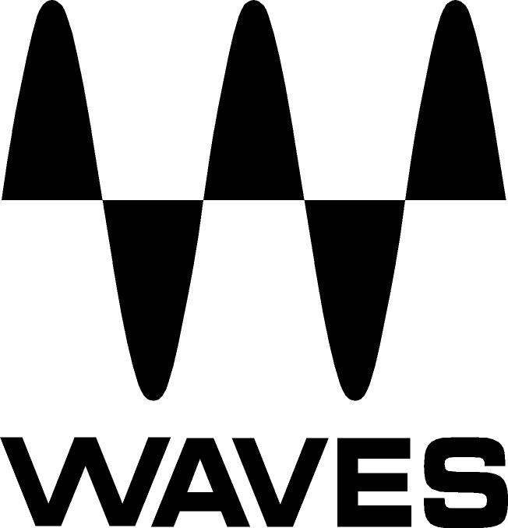
PRESS RELEASE
Contact: Clyne Media, Inc.
Tel: (615) 662-1616

FOR IMMEDIATE RELEASE

Waves Now Shipping the CR8 Creative Sampler and the COSMOS AI-Powered Sample Finder

Knoxville, TN, February 17, 2022 — Waves Audio, the world’s leading developer of professional audio signal processing technologies and plugins, is now shipping the CR8 Creative Sampler, together with the built-in COSMOS AI-powered Sample Finder and over 2,500 free samples.

The Waves CR8 Creative Sampler takes all of the most powerful creative sample manipulation options and puts them in one easy workflow, so you can get creative fast. With CR8 you can turn any sound into an inspiring playable instrument in seconds – with the easiest access to:
- Eight sample layers, allowing you stack and mix samples, or split them across your keys
- Five stretching algorithms – Voice, Beats, Melodic, Harmonic and Classic – each allowing you to control pitch and time independently
- Key & BPM analysis to get you in tune and in sync with your session in seconds
- Easy Loop, Reverse, Freeze options and more, for instant control over your sample playback

In addition, you can shape color and timbre using the built-in filters and ADSR envelopes, with drag-and-drop assignment of four powerful LFO/Sequencer modulators and four ADSR envelopes to practically any CR8 control. You can also assign your keyboard’s aftertouch, velocity, mod-wheel and pitch-wheel to most of CR8’s controls, making your samples playable in a responsive musical way.

CR8 also includes the built-in Waves COSMOS, an AI-powered Sample Finder that sorts all the one-shots and loops on your computer and auto-tags them by instrument, key, BPM and other musical characteristics. With COSMOS, you can find any sample in your collection quickly and easily. With CR8 and COSMOS working together, you can browse and audition all your samples right from within the CR8 sampler, while the track is playing, in the context of your session, without leaving your creative workflow to search for sounds.

CR8 comes with over 800 sampler presets, plus over 2500 free one-shots and loops (included with COSMOS).

CR8 Creative Sampler Features:
- The most creative sampler options in a fast and easy workflow
- Eight sample layers to create rich sample textures
- Stack and mix the eight layers, or split them across your keyboard
- Five stretching algorithms: Voice, Beats, Melodic, Harmonic, Classic
- Play and Launch modes
- Root and BPM detection
- Drag and drop four LFO/Sequencers and four ADSR modulators on any CR8 control
- Individual Cutoff, Resonance and Drive for each sample with four assignable group filters
- Assign keyboard functions to CR8 controls for extra playability
- Internal sample mixer with tune, pan and width settings
- Includes the COSMOS AI-powered Sampler Finder
- Over 2500 free samples (with the built-in COSMOS)
- Over 800 creative sampler presets

Waves C48 Creative Sampler videos:
- NEW Waves CR8 Sampler | Create Infinite Instruments. Quicker: https://youtu.be/RDyPOjQZ6Wc
- 5 MUST-KNOW Sampling Tricks | CR8 Creative Sampler: https://youtu.be/9IhHwTmgTv4

…ends 418 words

Photo file 1: CR8.JPG
Photo caption 1: Waves CR8 Creative Sampler interface

About Waves Audio Ltd.:
Waves is the world’s leading developer of audio DSP solutions for music production, recording, mixing, mastering, sound design, post-production, live sound, broadcast, commercial and consumer electronics audio markets. Since its start in the early '90s, Waves has developed a comprehensive line of over 250 audio plugins and numerous hardware devices. For its accomplishments, Waves received a Technical GRAMMY® Award in 2011, and its early flagship plugin, the Q10 equalizer, was selected as an inductee into the TECnology Hall of Fame.

Increasingly leveraging pioneering techniques in artificial intelligence, neural networks and machine learning, as well as the company’s three decades of accumulated expertise in psychoacoustics, Waves technologies are being used to improve sound quality in a growing number of market sectors. Around the world, Waves’ award-winning plugins are utilized in the creation of hit records, major motion pictures, and top-selling video games. Additionally, Waves now offers hardware-plus-software solutions (including the revolutionary eMotion LV1 mixer) for professional audio markets. The company’s WavesLive division is a leader in the live sound sector, spearheading the development of solutions for all live platforms. Products from Waves Commercial Audio enable A/V system integrators and installers to deliver superior sound quality for corporate, commercial, government, educational, entertainment, sports and house-of-worship applications. Under its Maxx brand, Waves offers semiconductor and licensable algorithms for consumer electronics applications, used in laptops, smartphones, smart speakers, gaming headsets, TVs and more from industry leaders such as Dell, Google, Fitbit, Acer, Asus, Hisense and others.

North America Offices:
Waves, Inc., 2800 Merchants Drive, Knoxville, TN 37912;
Tel: 865-909-9200, Fax: 865-909-9245, Email: info@waves.com,
Web: http://www.waves.com

Corporate Headquarters Israel:
Waves Ltd., Azrieli Center, The Triangle Tower, 32nd Floor, Tel Aviv 67023, Israel;
Tel: 972-3-608-4000, Fax: 972-3-608-4056, Email: info@waves.com,
Web: http://www.waves.com

Waves Public Relations:
Clyne Media, Inc., 169-B Belle Forest Circle, Nashville, TN 37221;
Tel: 615-662-1616, Email: robert@clynemedia.com,
Web: http://www.clynemedia.com

