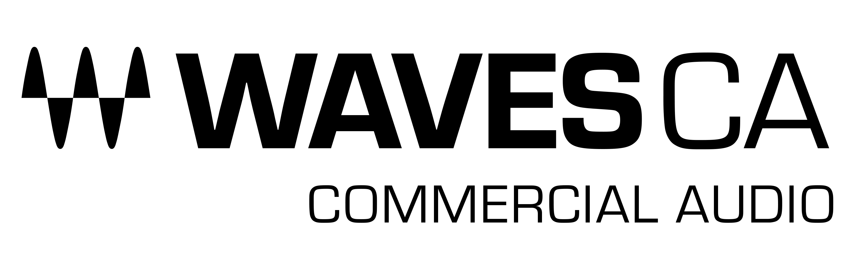

PRESS RELEASE
Contact: Clyne Media, Inc.
Tel: (615) 662-1616

FOR IMMEDIATE RELEASE

Waves Cloud MX Audio Mixer Supports Deployment on Amazon Web Services (AWS) for Cloud Based Productions

InfoComm, Las Vegas, NV, June 8, 2022 — Waves Audio (booth W1912), the world’s leading developer of professional audio signal processing technologies and plugins, announces support for Amazon Web Services (AWS) with the Waves Cloud MX Audio Mixer, a cloud-based professional audio mixer with superior sound quality for broadcast productions.

As broadcast and media organizations transition to cloud-based production environments, they need to meet the growing demand for feature-rich content and over-the-top (OTT) distribution. At the core of these next-generation workflows are cloud-based production tools that enable remote integration (REMI) and distributed operations. Waves’ Cloud MX Audio Mixer can now be integrated into cloud production environments to process and distribute high-quality audio for media content distributed to a regional or global audience.

Waves Cloud MX Audio Mixer is utilized by customers on Amazon Elastic Compute Cloud (Amazon EC2) to ensure that secure, reliable, high-performance and cost-effective compute infrastructure is available throughout an event. Customers can use the mixer on instances in any of the available Amazon EC2 geographical locations to optimize network performance between the cloud, remote operators, and on-premise equipment.

With Waves’ Cloud MX Audio Mixer operating on AWS, broadcast professionals enjoy a superior-sounding cloud-based mixer; scalable processing resources to match the event requirements and budget; secure cloud access, which enables production staff to work from anywhere while protecting broadcast media and data; reduced operational costs through streamlined staff scheduling and consolidated workflows; and reduced capital expenditures using scalable cloud resources in place of on-premise and OB hardware investments.

The Waves Cloud MX Audio Mixer is NDI®-compatible, fitting easily into NDI-based environments, with easy patching and routing of NDI audio streams to simplify integration with the entire cloud production system. The cloud-based deployment also makes it easy to scale productions. Any number of audio mixers can be used simultaneously without the operational costs involved in shipping, maintaining, or scheduling on-premise gear and personnel.

Broadcasters and media organizations using Waves’ Cloud MX Audio Mixer can now ensure an enhanced professional final production mix. The state-of-the-art audio mixing and processing of Cloud MX Audio Mixer is powered by a cloud-based version of Waves’ crystal-clear, double-precision, 32-bit floating-point eMotion LV1 mixing engine, augmented by Waves’ industry-leading arsenal of cloud-licensed audio plugins.

All Waves Cloud MX Audio Mixer packages come with the powerful cloud-licensed Waves eMo plugins (eMo D5 Dynamics, eMo F2 Filter, and eMo Q4 Equalizer), which form the mixer’s channel strip for a fast, efficient workflow. Users can expand their audio capabilities even further by upgrading to Cloud MX Audio Mixer Plus, with 11 extra cloud-licensed plugins such as the Primary Source Expander for automatic mic bleed elimination, the legendary Renaissance Vox vocal compressor, the surgical F6 Floating-Band Dynamic EQ, MaxxBass, the L2 UltraMaximizer and more; or to Cloud MX Audio Mixer Premium, which adds over 150 cloud-licensed plugins covering every audio need, including the Dugan Speech plugin for real-time automatic mixing of multiple mics. Each of these packages is available as 1-month or 1-year licenses.

With Waves’ Cloud MX Audio Mixer on AWS, broadcasters can now achieve unmatched pro audio quality with precision control in their cloud production environment.

To learn more, click here.

…ends 516 words

About Waves Audio Ltd.:
Waves is the world’s leading developer of audio DSP solutions for music production, recording, mixing, mastering, sound design, post-production, live sound, broadcast, commercial and consumer electronics audio markets. Since its start in the early '90s, Waves has developed a comprehensive line of over 250 audio plugins and numerous hardware devices. For its accomplishments, Waves received a Technical GRAMMY® Award in 2011, and its early flagship plugin, the Q10 equalizer, was selected as an inductee into the TECnology Hall of Fame.

Increasingly leveraging pioneering techniques in artificial intelligence, neural networks and machine learning, as well as the company’s three decades of accumulated expertise in psychoacoustics, Waves technologies are being used to improve sound quality in a growing number of market sectors. Around the world, Waves’ award-winning plugins are utilized in the creation of hit records, major motion pictures, and top-selling video games. Additionally, Waves now offers hardware-plus-software solutions (including the revolutionary eMotion LV1 mixer) for professional audio markets. The company’s WavesLive division is a leader in the live sound sector, spearheading the development of solutions for all live platforms. Products from Waves Commercial Audio enable A/V system integrators and installers to deliver superior sound quality for corporate, commercial, government, educational, entertainment, sports and house-of-worship applications. Under its Maxx brand, Waves offers semiconductor and licensable algorithms for consumer electronics applications, used in laptops, smartphones, smart speakers, gaming headsets, TVs and more from industry leaders such as Dell, Google, Fitbit, Acer, Asus, Hisense and others.

North America Offices:
Waves, Inc., 2800 Merchants Drive, Knoxville, TN 37912;
Tel: 865-909-9200, Fax: 865-909-9245, Email: info@waves.com,
Web: http://www.waves.com

Corporate Headquarters Israel:
Waves Ltd., Azrieli Center, The Triangle Tower, 32nd Floor, Tel Aviv 67023, Israel;
Tel: 972-3-608-4000, Fax: 972-3-608-4056, Email: info@waves.com,
Web: http://www.waves.com

Waves Public Relations:
Clyne Media, Inc., 169-B Belle Forest Circle, Nashville, TN 37221;
Tel: 615-662-1616, Email: robert@clynemedia.com,
Web: http://www.clynemedia.com

Waves Audio is exhibiting at booth W1912 at the 2022 InfoComm Show in Las Vegas, NV.

