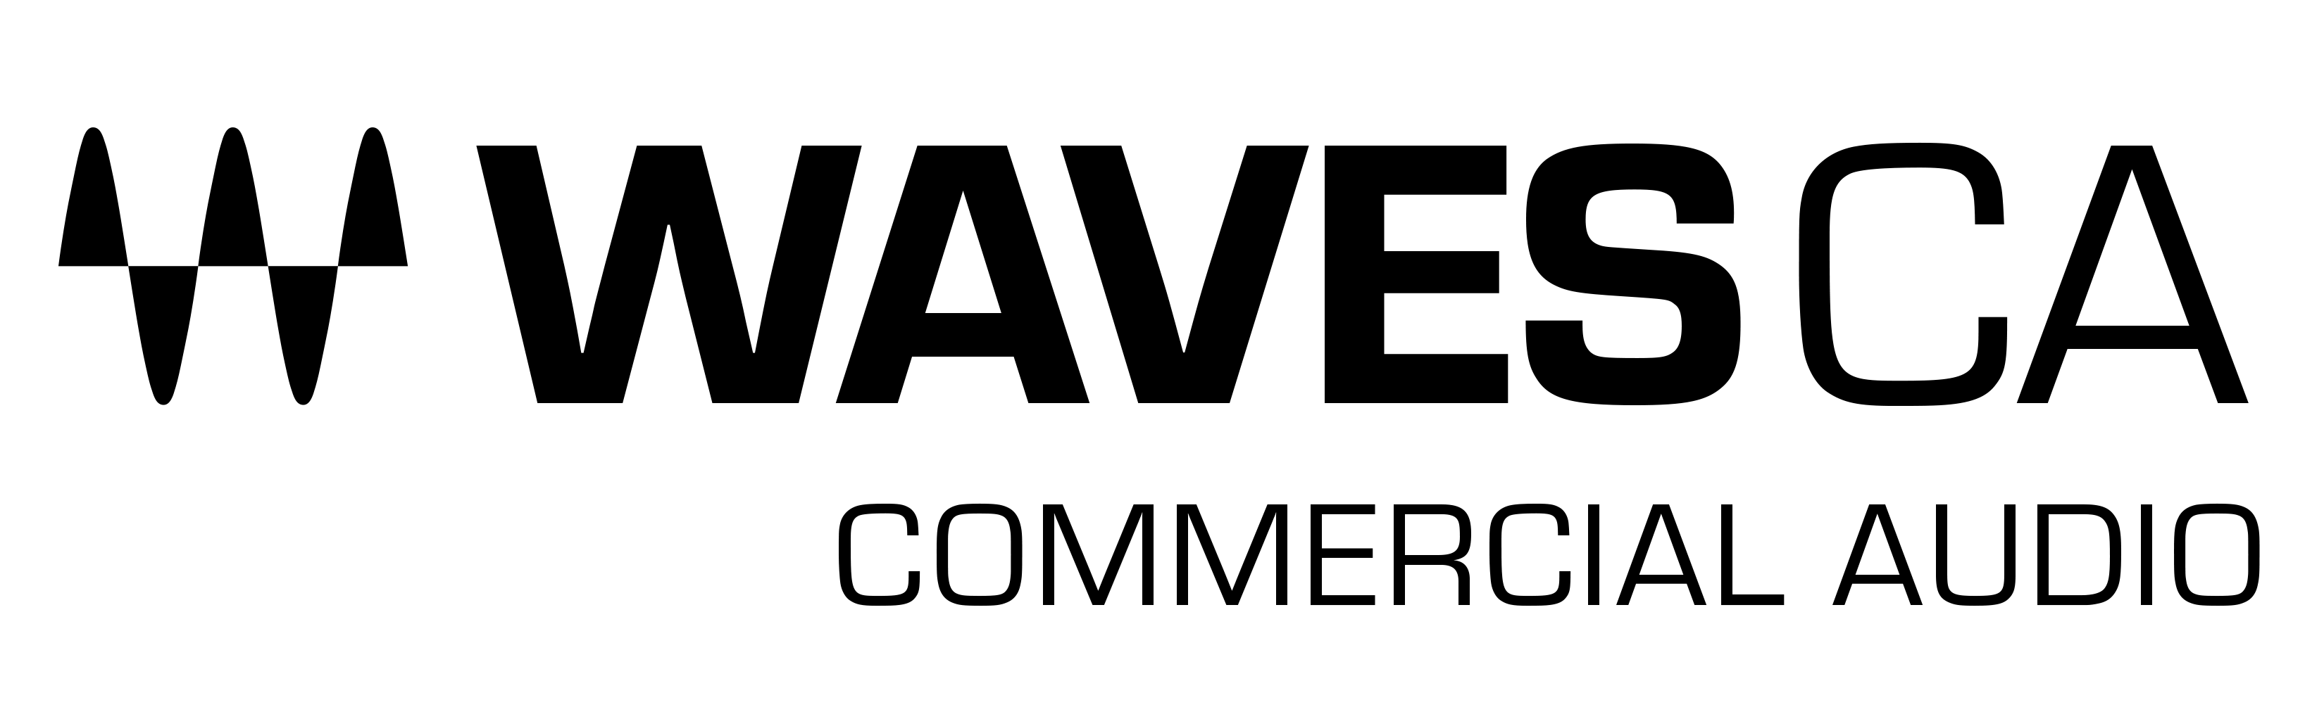
PRESS RELEASE
Contact: Clyne Media, Inc.
Tel: (615) 662-1616

FOR IMMEDIATE RELEASE

Waves Audio Exhibits Its Proton Duo with SuperRack

InfoComm, Las Vegas, NV, June 8, 2022 — Waves Audio (booth W1912) is exhibiting the Proton Duo, which combines a Waves Proton SoundGrid® server, an Axis Proton audio-optimized computer, and a built-in network switch – all in one compact device.

For the first time ever, you can add more plugin processing power via a Waves SoundGrid® server, and run Waves applications on a customized computer designed for outstanding audio performance – all using one slim elegant unit, instead of two separate devices.
In addition to boosting your DSP power, the Proton Duo is optimized through meticulous selection of components to run the Waves eMotion LV1 live mixer, the Waves SuperRack live plugin host, and the SoundGrid® Studio application, on systems of up to 32 channels.
With server, computer and switch all rolled into one, the Proton Duo is the most compact and portable Waves processing unit yet. Easily mount using rack ears or placed side-by-side with an additional half-rack 1U device within a rack mounting system. Preconfigured, wired, and ready to go straight out of the box, Proton Duo is designed for quick setup: Just plug it into your I/O, anytime, anywhere -- and you’re ready to mix.

Learn more here.
…ends 191 words

Photo file 1: Waves_Proton_Duo.JPG
Photo caption 1: Waves Proton Duo combines a Waves Proton SoundGrid® server, an Axis Proton audio-optimized computer, and a built-in network switch – all in one compact device

About Waves Audio Ltd.:
Waves is the world’s leading developer of audio DSP solutions for music production, recording, mixing, mastering, sound design, post-production, live sound, broadcast, commercial and consumer electronics audio markets. Since its start in the early '90s, Waves has developed a comprehensive line of over 250 audio plugins and numerous hardware devices. For its accomplishments, Waves received a Technical GRAMMY® Award in 2011, and its early flagship plugin, the Q10 equalizer, was selected as an inductee into the TECnology Hall of Fame.

Increasingly leveraging pioneering techniques in artificial intelligence, neural networks and machine learning, as well as the company’s three decades of accumulated expertise in psychoacoustics, Waves technologies are being used to improve sound quality in a growing number of market sectors. Around the world, Waves’ award-winning plugins are utilized in the creation of hit records, major motion pictures, and top-selling video games. Additionally, Waves now offers hardware-plus-software solutions (including the revolutionary eMotion LV1 mixer) for professional audio markets. The company’s WavesLive division is a leader in the live sound sector, spearheading the development of solutions for all live platforms. Products from Waves Commercial Audio enable A/V system integrators and installers to deliver superior sound quality for corporate, commercial, government, educational, entertainment, sports and house-of-worship applications. Under its Maxx brand, Waves offers semiconductor and licensable algorithms for consumer electronics applications, used in laptops, smartphones, smart speakers, gaming headsets, TVs and more from industry leaders such as Dell, Google, Fitbit, Acer, Asus, Hisense and others.

North America Offices:
Waves, Inc., 2800 Merchants Drive, Knoxville, TN 37912;
Tel: 865-909-9200, Fax: 865-909-9245, Email: info@waves.com,
Web: http://www.waves.com

Corporate Headquarters Israel:
Waves Ltd., Azrieli Center, The Triangle Tower, 32nd Floor, Tel Aviv 67023, Israel;
Tel: 972-3-608-4000, Fax: 972-3-608-4056, Email: info@waves.com,
Web: http://www.waves.com

Waves Public Relations:
Clyne Media, Inc., 169-B Belle Forest Circle, Nashville, TN 37221;
Tel: 615-662-1616, Email: robert@clynemedia.com,
Web: http://www.clynemedia.com

Waves Audio is exhibiting at booth W1912 at the 2022 InfoComm Show in Las Vegas, NV.

