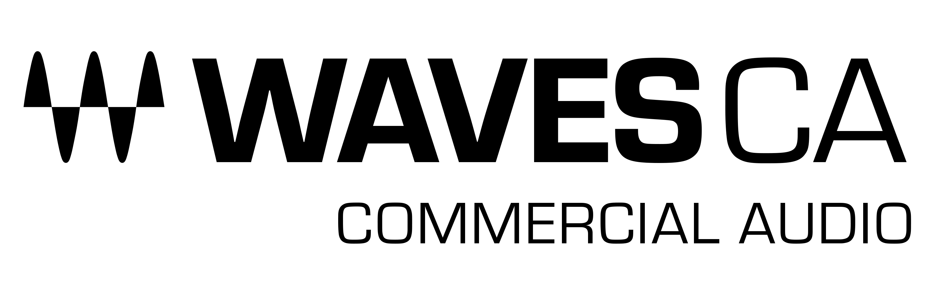

PRESS RELEASE
Contact: Clyne Media, Inc.
Tel: (615) 662-1616

FOR IMMEDIATE RELEASE

Waves Shows Its Complete Range of System Integration Solutions at InfoComm

Knoxville, TN, May 31, 2022 – Waves Audio, the world’s leading developer of professional audio signal processing technologies and plugins, will be showing its complete range of System Integration Solutions from its line of Commercial Audio products at InfoComm 2022 (booth W1912). Highlights include the new Waves Cloud MX Mixer; the CA3000-MX, CA2000 and CA3000 Commercial Audio Mixer & DSP Engines; Waves eMotion LV1; Waves Proton Duo with SuperRack; My FOH App; and more.

The new Waves Cloud MX Audio Mixer is a 100% cloud-based audio mixer with superior sound quality for cloud broadcast environments. Cloud MX Audio Mixer delivers pristine audio, high-precision mix control and creative processing capabilities with full Waves cloud-licensed plugin integration – all in a scalable, remotely operated, broadcast-ready cloud workflow running on a 32-bit-float mixing engine. Waves’ Cloud MX Audio Mixer is compatible with NDI® (Network Device Interface), fitting easily into NDI-based environments, with easy patching and routing of NDI audio streams. It is also easily deployed on Amazon Web Services (AWS), making integration with cloud production systems a breeze.

Cloud MX Audio Mixer makes it easy to scale productions with any number of audio mixers, without the operational costs involved in shipping, maintaining, or scheduling on-premise gear and personnel.
All Waves Cloud MX Audio Mixer packages come with the powerful cloud-licensed Waves eMo plugins (eMo D5 Dynamics, eMo F2 Filter, and eMo Q4 Equalizer), which form the mixer’s channel strip for a fast, efficient workflow. Audio capabilities can be expanded even further by upgrading to either Cloud MX Audio Mixer Plus, with 11 extra cloud-licensed plugins such as the Primary Source Expander for automatic mic bleed elimination, the legendary Renaissance Vox vocal compressor, the surgical F6 Floating-Band Dynamic EQ, MaxxBass, the L2 UltraMaximizer and more; or to Cloud MX Audio Mixer Premium, which adds over 150 cloud-licensed plugins covering every audio need, including the Dugan Speech plugin for real-time automatic mixing of multiple mics.

Waves’ CA3000-MX Commercial Audio Mixer is a new install-ready audio mixer and processing engine that delivers stellar sound quality for a wide range of single-room and multi-zone AV installations. The CA3000-MX offers powerful mixing and built-in processing capabilities with the option to expand processing, by adding plugins from Waves’ massive catalog (to customize processing to specific needs).

The CA3000-MX is ideal for a wide range of applications, including corporate, commercial, government, educational or house-of-worship installation. Housed in a compact half-width 2U rack-mount chassis, CA3000-MX couples a powerful digital audio processing engine with an install-ready version of the industry-proven Waves eMotion LV1 Live Mixer, supporting up to 32 stereo inputs, 24 stereo aux mix outputs plus L/R/C/M outs, and a 12x8 stereo matrix. Integration and setup of the system is simple: CA3000-MX integrates easily with standard ASIO audio device drivers, or with Dante® Virtual Soundcard (DVS) audio networking.

Waves plugins can be added to address feedback suppression, dynamics control, source leveling, noise reduction, acoustic response, broadcast streaming optimization, and more. Installations that require automatic mixing of multiple live microphones (such as corporate and government discussion panels), can also add the Waves Dugan Speech plugin as an optional purchase. Powered by Dan Dugan's patented voice-activated process, Dugan Speech controls the gains of multiple microphones automatically and in real time, dramatically reducing noise, feedback and comb filtering from adjacent microphones. This capability offers integrators a superior solution for discussion panels, faith-based services and events, conferences, and any other event involving several microphones and multiple participants. End users can easily control preconfigured, fully customized audio settings, using the Waves mRecall audio scene recall app.

Also being shown are new updated versions of the Waves CA1000 and CA2000 Commercial Audio DSP Engines, now featuring more integration options: in addition to Dante compatibility, these units are now also ASIO-compatible. Furthermore, users can now control customized CA1000 and CA2000 settings remotely with the Waves mRecall Audio Scene & Snapshot App.

The new Waves MyFOH tablet app has been the number-one most-requested feature by live sound engineers using the Waves eMotion LV1 live mixer. MyFOH allows front-of-house engineers to control the LV1 over WiFi, from any iPad or Android tablet, and shape the live mix from anywhere in the venue. With MyFOH, engineers can walk the venue and evaluate their mix from the vantage point of the audience and adjust levels, panning and much more, for individual channels as well as groups, auxes, FX groups, DCAs and matrixes. MyFOH also allows the user to correct levels for front fills and delays, which are almost impossible to judge confidently from the static FOH position. Users handling both FOH and monitor duties at the same show can also use MyFOH next to the musicians on stage (rather than attempting effective communication from across the venue), creating a more personal, nuanced and professional experience for all involved. To learn more, click here.

The Waves Proton Duo with SuperRack combines a Waves Proton SoundGrid® server, an Axis Proton audio-optimized computer, and a built-in network switch – all in one compact device. For the first time ever, users can add more plugin processing power via a Waves SoundGrid® server, and run Waves applications on a customized computer designed for outstanding audio performance – all using one slim elegant unit, instead of two separate devices. In addition to boosting DSP power, the Proton Duo is optimized through meticulous selection of components to run the Waves eMotion LV1 live mixer, the Waves SuperRack live plugin host, and the SoundGrid® Studio application, on systems of up to 32 channels. With server, computer and switch all rolled into one, the Proton Duo is the most compact and portable Waves processing unit yet. Users can easily mount Proton Duo using rack ears or placed side-by-side with an additional half-rack 1U device within a rack-mounting system. Preconfigured, wired, and ready to go straight out of the box, Proton Duo is designed for quick setup: users can just plug it into their I/O, anytime, anywhere, and you’re ready to mix. Learn more here.

Waves Commercial Audio products offer dramatically improved audio playback and intelligibility with professional curated solutions, ready to go in any Dante or ASIO-based installation.

…ends 1005 words

Photo file 1: CloudMX_AudioMixer.JPG
Photo caption 1: Waves Cloud MX Audio Mixer

About Waves Audio Ltd.:
Waves is the world’s leading developer of audio DSP solutions for music production, recording, mixing, mastering, sound design, post-production, live sound, broadcast, commercial and consumer electronics audio markets. Since its start in the early '90s, Waves has developed a comprehensive line of over 250 audio plugins and numerous hardware devices. For its accomplishments, Waves received a Technical GRAMMY® Award in 2011, and its early flagship plugin, the Q10 equalizer, was selected as an inductee into the TECnology Hall of Fame.

Increasingly leveraging pioneering techniques in artificial intelligence, neural networks and machine learning, as well as the company’s three decades of accumulated expertise in psychoacoustics, Waves technologies are being used to improve sound quality in a growing number of market sectors. Around the world, Waves’ award-winning plugins are utilized in the creation of hit records, major motion pictures, and top-selling video games. Additionally, Waves now offers hardware-plus-software solutions (including the revolutionary eMotion LV1 mixer) for professional audio markets. The company’s WavesLive division is a leader in the live sound sector, spearheading the development of solutions for all live platforms. Products from Waves Commercial Audio enable A/V system integrators and installers to deliver superior sound quality for corporate, commercial, government, educational, entertainment, sports and house-of-worship applications. Under its Maxx brand, Waves offers semiconductor and licensable algorithms for consumer electronics applications, used in laptops, smartphones, smart speakers, gaming headsets, TVs and more from industry leaders such as Dell, Google, Fitbit, Acer, Asus, Hisense and others.

North America Offices:
Waves, Inc., 2800 Merchants Drive, Knoxville, TN 37912;
Tel: 865-909-9200, Fax: 865-909-9245, Email: info@waves.com,
Web: http://www.waves.com

Corporate Headquarters Israel:
Waves Ltd., Azrieli Center, The Triangle Tower, 32nd Floor, Tel Aviv 67023, Israel;
Tel: 972-3-608-4000, Fax: 972-3-608-4056, Email: info@waves.com,
Web: http://www.waves.com

Waves Public Relations:
Clyne Media, Inc., 169-B Belle Forest Circle, Nashville, TN 37221;
Tel: 615-662-1616, Email: robert@clynemedia.com,
Web: http://www.clynemedia.com

