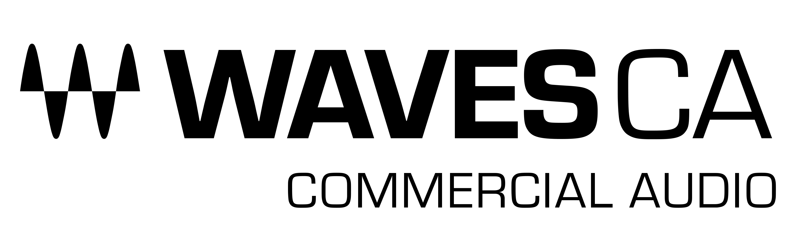

PRESS RELEASE
Contact: Clyne Media, Inc.
Tel: (615) 662-1616

FOR IMMEDIATE RELEASE

Waves Displays the CA3000-MX Commercial Audio Mixer for A/V System Integrators & Installers

InfoComm, Orlando, FL, June 14, 2023 — Waves Audio (booth 5868), the world’s leading developer of professional audio signal processing technologies and plugins, is exhibiting the CA3000-MX Commercial Audio Mixer, an install-ready audio mixer and processing engine that delivers stellar sound quality for a wide range of single-room and multi-zone AV installations. CA3000-MX offers powerful mixing and built-in processing capabilities that can upgrade the sound of any installed audio system; it also offers the option to expand processing, by adding plugins from Waves’ massive catalog. The CA3000-MX system is compatible with standard ASIO audio or Dante® network configurations.

CA3000-MX is ideal for any corporate, commercial, government, educational or house-of-worship installation that demands a high level of audio quality and advanced processing flexibility. Housed in a compact half-width 2U rack-mount chassis, CA3000-MX couples a powerful digital audio processing engine with an install-ready version of the industry-proven Waves eMotion LV1 mixer, supporting up to 32 stereo inputs, 24 stereo aux mix outputs plus L/R/C/M outs, and a 12x8 stereo matrix.

Integration and setup of the system is simple: CA3000-MX integrates easily with standard ASIO audio device drivers, or with Dante® Virtual Soundcard (DVS) audio networking.

Integrators can add any desired Waves plugins to the CA3000-MX, to customize the processing to their specific needs. Waves offers a massive selection of audio processing plugins to address issues with feedback suppression, dynamics control, source leveling, noise reduction, acoustic response, broadcast streaming optimization, and more.

Installations that require automatic mixing of multiple live microphones (such as corporate and government discussion panels), can also add the Waves Dugan Speech plugin as an optional purchase. Powered by Dan Dugan's patented voice-activated process, Dugan Speech controls the gains of multiple microphones automatically and in real time, dramatically reducing noise, feedback and comb filtering from adjacent microphones. This capability offers integrators a superior solution for discussion panels, faith-based services and events, conferences, and any other event involving several microphones and multiple participants.

End-users can easily control preconfigured, fully customized audio settings, using the Waves mRecall audio scene recall app, to deliver superior sound quality to any commercial space.

Also available are updated versions of the Waves CA1000 and CA2000 Commercial Audio DSP Engines, now featuring more integration options: in addition to Dante compatibility, these units are now also ASIO-compatible. Furthermore, you can now control customized CA1000 and CA2000 settings remotely with the Waves mRecall Audio Scene & Snapshot App.

CA 3000-MX features:
- Studio-grade audio processing quality for AV installations
- License includes an install-ready version of the Waves eMotion LV1 audio mixer
- Integrate quickly with your choice of vendor audio preamps, mics, line sources and amplifiers/speakers
- ASIO-compatible (USB or Ethernet)
- Dante®-compatible (1Gb Ethernet port)
- Two versions available: 32 or 16 mono/stereo inputs
- Up to 24 stereo aux mix and L/R/C/M outputs
- 12x8 mono/stereo matrix
- Includes eMo D5 Dynamics, eMo F2 Filter, eMo Q4 Equalizer, eMo Generator plugins
- Integrates smoothly with the Dugan Speech plugin
- Supports integrator addition of Waves plugins
- Control pre-configured, customized scenes with mRecall mobile app
- Integrator configuration: USB and HDMI/DisplayPort
- Operating environment: Windows 10 and Dante Virtual Soundcard (DVS) included
- Half-width, 2U rack- or surface-mount chassis
- Free 1-year warranty

Waves Commercial Audio products offer dramatically improved audio playback and intelligibility with professional curated solutions, ready to go in any Dante or ASIO-based installation.

To learn more about CA3000-MX, click here.
To learn more about Waves CA/Commercial Audio, click here.

…ends 581 words

Photo file: Waves_CA3000.JPG
Photo caption: Waves CA3000-Mx Commercial Audio Mixer & DSP Engine

About Waves Audio Ltd.:
Waves is the world’s leading developer of audio DSP solutions for music production, recording, mixing, mastering, sound design, post-production, live sound, broadcast, commercial and consumer electronics audio markets. Since its start in the early '90s, Waves has developed a comprehensive line of over 250 audio plugins and numerous hardware devices. For its accomplishments, Waves received a Technical GRAMMY® Award in 2011, and its early flagship plugin, the Q10 equalizer, was selected as an inductee into the TECnology Hall of Fame.

Increasingly leveraging pioneering techniques in artificial intelligence, neural networks and machine learning, as well as the company’s three decades of accumulated expertise in psychoacoustics, Waves technologies are being used to improve sound quality in a growing number of market sectors. Around the world, Waves’ award-winning plugins are utilized in the creation of hit records, major motion pictures, and top-selling video games. Additionally, Waves now offers hardware-plus-software solutions (including the revolutionary eMotion LV1 mixer) for professional audio markets. The company’s WavesLive division is a leader in the live sound sector, spearheading the development of solutions for all live platforms. Products from Waves Commercial Audio enable A/V system integrators and installers to deliver superior sound quality for corporate, commercial, government, educational, entertainment, sports and house-of-worship applications. Under its Maxx brand, Waves offers semiconductor and licensable algorithms for consumer electronics applications, used in laptops, smartphones, smart speakers, gaming headsets, TVs and more from industry leaders such as Dell, Google, Fitbit, Acer, Asus, Hisense and others.

North America Offices:
Waves, Inc., 2800 Merchants Drive, Knoxville, TN 37912;
Tel: 865-909-9200, Fax: 865-909-9245, Email: info@waves.com,
Web: http://www.waves.com

Corporate Headquarters Israel:
Waves Ltd., Azrieli Center, The Triangle Tower, 32nd Floor, Tel Aviv 67023, Israel;
Tel: 972-3-608-4000, Fax: 972-3-608-4056, Email: info@waves.com,
Web: http://www.waves.com

Waves Public Relations:
Clyne Media, Inc., 169-B Belle Forest Circle, Nashville, TN 37221;
Tel: 615-662-1616, Email: robert@clynemedia.com,
Web: http://www.clynemedia.com

